**IOT & Cyber Security**

~Week 4-5~

Kali Linux

We are asked to create reflection by reading following links and apply the steps which include detailed information about Kali Linux.

* <https://medium.com/analytics-vidhya/a-comprehensive-guide-to-kali-linux-essentials-and-beyond-ae29298c3be3>
* <https://www.geeksforgeeks.org/top-10-kali-linux-tools-for-hacking/>

**Introduction:**

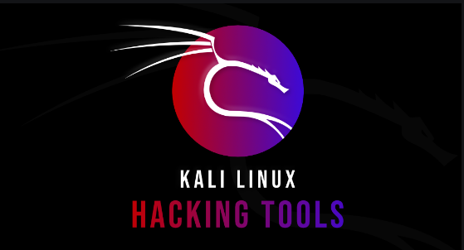Linux is a free and open-source operating system that was first released in 1991 by Linus Torvalds. It is based on the Unix operating system and is often used as an alternative to proprietary operating systems such as Microsoft Windows or MacOS. One of the key benefits of Linux is that it is highly customizable and can be tailored to meet the specific needs of an individual or organization. It is also known for being stable, secure, and efficient.

Linux is used in a wide range of applications, including personal computers, servers, mobile devices, and embedded systems. It is also a popular choice for programming and development due to the availability of a wide range of tools and resources.

Overall, Linux is a powerful and versatile operating system that has gained widespread adoption in the technology industry. It has a strong community of users and developers who contribute to its ongoing development and improvement.

**Why Kali?**

* Includes more than 600 Penetration Testing Tools
* Free to use (if your time has no value)
* Operates on Open-Source Development Model
* Gives freedom to customize completely
* Developed in a secure environment
* Custom kernel, patched for injection
* ARMEL and ARMHF support
* Diverse and vibrant community

There are some popular lists of tools used in Linux to save time and effort.

1. Text

   Description automatically generatedA screenshot of a computer

   Description automatically generated with medium confidence**Nmap:** Nmap is an open-source network scanner that is used to recon/scan networks. It is used to discover hosts, ports, and services along with their versions over a network. 
2. Graphical user interface, text, application, email

   Description automatically generated**Burp Suite:** Burp Suite is one of the most popular web application security testing software. It is used as a proxy, so all the requests from the browser with the proxy pass through it. And as the request passes through the burp suite, it allows us to make changes to those requests as per our need which is good for testing vulnerabilities like XSS or SQLi or even any vulnerability related to the web.
3. **Wireshark:** Wireshark is a network security tool used to analyze or work with data sent over a network. It is used to analyze the packets transmitted over a network. These packets may have information like the source IP and the destination IP, the protocol used, the data, and some headers.

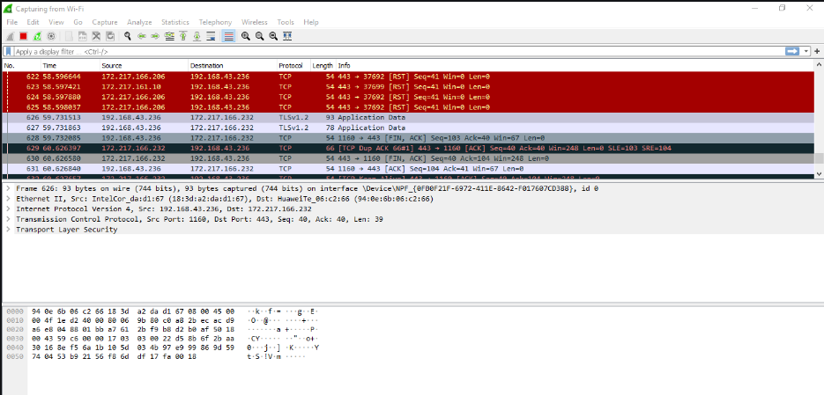

1. Text

   Description automatically generated**metasploit Framework:** Metasploit is an open-source tool that was designed by Rapid7 technologies. It is one of the world’s most used penetration testing frameworks. It comes packed with a lot of exploits to exploit the vulnerabilities over a network or operating systems. Metasploit generally works over a local network, but we can use Metasploit for hosts over the internet using “port forwarding “
2. **Autopsy:** is all in one forensic utility for fast data recovery and hash filtering. This tool carves deleted files and media from unallocated space using PhotoRec. It can also extract EXIF extension multimedia. Autopsy scans for compromise indicator using STIX library. It is available in the command line as well as GUI interface.(I have not tried it.)

**My Reflection on Kali Linux:**

**Conclusion:**

Kali Linux is a popular open-source operating system that is widely used for penetration testing and security assessments. It is a distribution of Linux that is specifically designed for these tasks and includes a wide range of tools and resources for identifying and addressing vulnerabilities in computer systems and networks.

Whether or not Kali Linux is the right operating system for a particular individual or organization will depend on their specific needs and goals. It is important to carefully evaluate the benefits and limitations of any operating system before deciding to use it.

**Problems faced while installing:**

**Problem Title:** No GUI after successful installation of Kali 2020.1

**Problem Description:**  As far as I searched, after installation is successful, GRUB is installed to MBR, but when I rebooted the system there was no grub splash screen; just a text based booting menu. After Kali booted up, there was no GUI; but only a text-based login option.

**Reason for the Problem:**  By spending some time googling it, I found that there is bug in 2020.1 installer ISO and about 140+ packages are missing in offline installer. Also, there are a few packages that are missing in APT package manager. To install Kali Linux with default options (XFCE DE), the installer needs an Internet connection to download missing packages from Kali repository. If you try to install Kali Linux offline, you will end up with text mode installation.

17330118 – Mustafa Guner